**Tip**

You can press the following keyboard shortcut combination to access *Settings* on Visual Studio Code:

***CTRL + ,*** (on Windows and Linux)

**CMD + ,**(on Mac)

In *Settings*, you can apply different customizations that fit your personal IDE style. For example, you can change the font settings of the text editor:

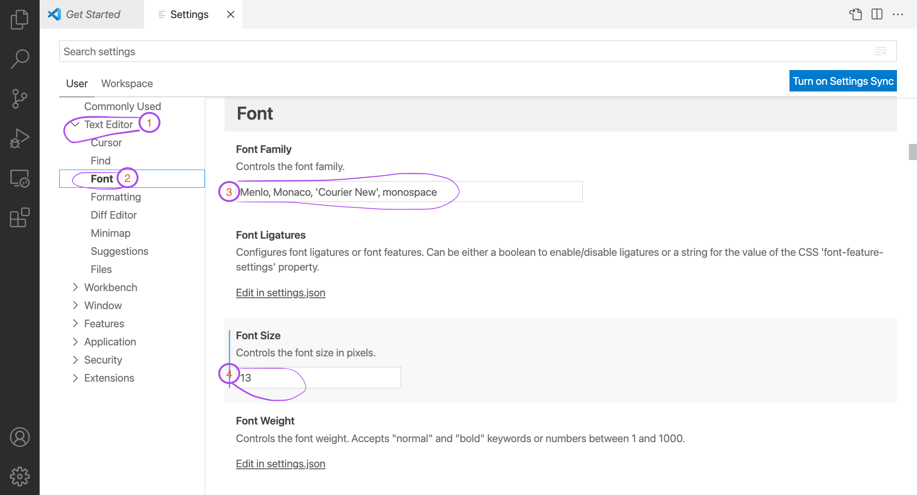

You can also search for a specific setting in the search box:

